**Course Project   
DeVry University  
College of Engineering and Information Sciences**

***Screenshot of program running:***

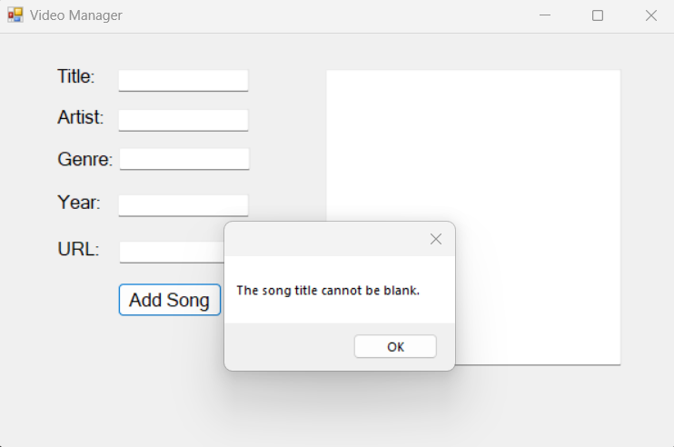

***Form code (only the code for the form, not program.cs):***

using System;

using System.Collections.Generic;

using System.ComponentModel;

using System.Data;

using System.Drawing;

using System.Linq;

using System.Text;

using System.Threading.Tasks;

using System.Windows.Forms;

namespace Rodriguez_CourseProject_Part1

{

public partial class MainForm : Form

{

public MainForm()

{

InitializeComponent();

}

private void addSongButton_Click(object sender, EventArgs e)

{

StringBuilder sb = new StringBuilder(outputText.Text);

string nl = "\r\n";

if (string.IsNullOrEmpty(titleText.Text))

{

// Title is blank

MessageBox.Show("The song title cannot be blank.");

}

else if (string.IsNullOrEmpty(artistText.Text))

{

// Artist is blank

MessageBox.Show("The artist cannot be blank.");

}

else if (string.IsNullOrEmpty(genreText.Text))

{

// Genre is blank

MessageBox.Show("The genre cannot be blank.");

}

else if (string.IsNullOrEmpty(yearText.Text))

{

// Year is blank

MessageBox.Show("The year cannot be blank.");

}

else if (string.IsNullOrEmpty(urlText.Text))

{

// URL is blank

MessageBox.Show("The url cannot be blank.");

}

else

{

// Add title to ListBox

songList.Items.Add(titleText.Text);

// Build the output text

sb.Append(titleText.Text);

sb.Append(nl);

sb.Append(artistText.Text);

sb.Append(nl);

sb.Append(genreText.Text);

sb.Append(nl);

sb.Append(yearText.Text);

sb.Append(nl);

sb.Append(urlText.Text);

sb.Append(nl);

sb.Append(nl);

outputText.Text = sb.ToString();

}

}

private void allSongsButton_Click(object sender, EventArgs e)

{

StringBuilder sb = new StringBuilder(String.Empty);

string nl = "\r\n";

// Build output text

foreach (var item in songList.Items)

{

sb.Append(item.ToString());

sb.Append(nl);

}

// Put the output text into the output textbox

outputText.Text = sb.ToString();

}

}

}